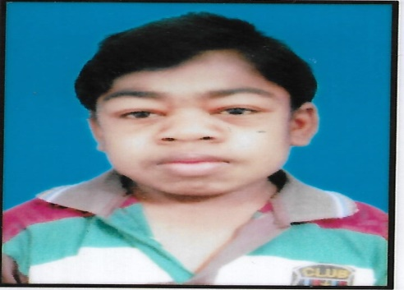

**ORDI Patients Registration form**

**Name of the Patient SURAJIT MALLICK**

**Sex Male**

**Age DOB: 13/10/2000**

**Kid is good at/Hobbies -NIL-**

**Name of the Father AKSHAY MALLICK**

**Name of the Mother MAYA MALLICK**

**Occupation of Father MASSION**

**Siblings other than Patient. Male : 2 Female : 1 Total: 3 Expired:**

**Name of Disease MUCOPOLYSACCHARIDOSIS DISEASE TYPE-II (MPS-II)**

**Name of the Hospital INSTITUTE OF CHILD HEALTH (ICH)**

**Name of the Doctor DR. SANA ISLAM**

**Contact Details of the 8100614274**

**Doctor/Hospital**

**Email ID of the doctor**

**Member Contact Details Phone No /Mobile 1: 9874487942**

**PhoneNo/Mobile 2: 7003229345**

**STD Code if landline**

**Member E mail ID Email ID 1:**rvforg@yahoo.com



**Correspondence Address**

**Full**

**Email ID 2:**

**Landmark: 58, BUS STAND**

**City : HOWRAH**

**Taluka :676, SARAT CHATTERJEE LANE**

**D,istrict : HOWRAH**

**PIN code :711102**

**Permanent Address if it is different from above**

**Referred by and Contact**

**Details**

**Landmark: 58, BUS STAND**

**City : HOWRAH**

**Taluka : 676, SARAT CHATTERJEE LANE**

**District : HOWRAH PIN code :711102(W.B)**



**Remarks**

I confirm the above details are true to the best of by knowledge. I agree to all the rules and regulations of the society and society decision is final.

**Date: Signature of the member**

**Note: Please attach any important photo /Information which you would like to share voluntarily.**

**For Office**

**Date of Membership Confirmation : Amount Paid in Rs. : Mode of Payment : Receipt no and Date : Membership No** : Member State : Member ID :

Accounts Treasurer

Please attach a Photo(Other)

**(Note: You can strike out for the pints not willing to provide consent)**

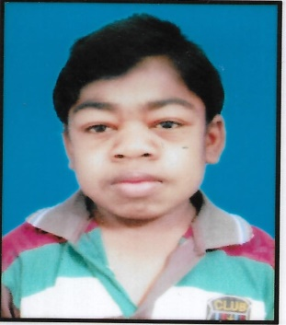

**ORDI – Patient Consent Form and Non-Disclosure Undertaking**

**Date:**

I, SURAJIT MALLICK , son/daughter/wife/father/Mother /Guardian of MAYA MALLICK

Photo f the RD

member /Patient

residing at HOWRAH

And suffering from MUCOPOLYSACCHARIDOSIS DISEASE TYPE-II (MPS-II) Disease, being a member of

ORDI bearing Membership No

wish to voluntarily participate in all the activities organized by ORDI and

agree to give my consent for the ORDI activities listed below in the interest of ORDI patients, parents and caregivers.



For discussing my disease and case history.

I hereby authorize ORDI to use my name, patient history, Medical records, treatment that I have undergone, history and any useful information in whatever form as may be necessary.

I do not hold ORDI for any claims/liabilities/obligations relating to privacy/confidentiality with respect to the disclosure of the aforesaid information for the purposes of the ORDI activity.

I hereby authorize ORDI to use my collected human sample for diagnostic or research purpose in India or abroad as deemed necessary by ORDI

I further authorize the Society to record and use any of the information by way of audio/video recording or any other form in whole or in part, for dissemination of information.

I also authorize ORDI to use my information, photo, video, Records to press, media or for research, publication, raising funds or any other useful purpose.

I acknowledge that any interaction and discussions with the ORDI society would be for my benefit. It would help in understanding in managing and treating my disease / disorders better.

I agree to any decision taken on my behalf for the betterment of my disorder and lifestyle.

I also agree to go wherever the society invites me for my betterment.

I acknowledge and understand that information- other ORDI member information, other patient information and medical details or any other information, that would be disclosed to me as a member of ORDI is confidential.

I hereby give an undertaking to the ORDI that I shall not disclose the any information to any third party and shall keep the same confidential. The above information has also been explained to me in a language I understand.

Patient/ Guardian’s Name (in case of minors):

Address: Contact Details: E mail ID: Signature: